Music already is relatively simple; we should keep the system simple and expand only when necessary. Certain tracks play at a higher priority than others. System music will always take priority if it’s being used, then combat music, then area music. The features this music system will use are:

* System music
* Combat music
* Area music

Additionally, there are two ways music can be stopped. Map triggers stop music in a different way than scripts can.

* Script stop music
* Map stop music

By using one of these features, a particular set of processes will happen to ensure a smooth experience.

There were some common issues the non-fmod system faced:

* Music had their duration manually input making looping the track usually not smooth.
* Could not fade out or between tracks.
* Many maps depended on independent script systems.

Under the proposed system, these issues should be resolved.

Each feature will be described in the order they take priority.

# System Music

The name implies a technical usage, which it should only be used for. The given track will play on a loop endlessly and cannot be stopped. It takes priority above any other track. The intended use is for holiday and event music. The only case system music will stop is if the map changes.

Script Usage:

playmp3 <playerId|all> system “musicFile.mp3”

Map Usage:

TODO

# Combat Music

Scripts control when combat music tracks will play. While combat music is playing, area triggers will save the area music on the client, but wont play until combat music is over. Combat music ends when either a trigger or script stops music.

Script Usage:

playmp3 <playerId|all> combat “musicFile.mp3”

Map Usage:

TODO

# Area Music

The intended use is for ambient music in a particular area. Area Music has the lowest priority to play. If System music or Combat music are playing, Area music wont play until those are done. Scripts cannot control area music.

Map Usage:

TODO

# Script Stop Music

Scripts can only stop combat music, since that is the only type of music (besides system, which can never be stopped) they can control. If combat music is playing, it will transition to the last area music trigger the player was in.

Script Usage:

playmp3 <playerId|all> stop //No mp3 file is given since we’re stopping music

# Stop Music

Map triggers can stop all music (except system). When a player walks into a trigger to stop music, the current track will fade out and nothing will play after until either area music, or combat music is set again.

Map usage:

TODO

# Potential Downfalls

This music system is very simple. Pressure should not be put on scripts to over complicate it. Because of its simplicity, issues may occur when using the system:

* System music gets annoying
  + Should be sparingly used. “stopsound” console cmd should be the only thing to stop system music. Players who used “stopsound” should be affected by area triggers normally again.
* Leans on scripts to work correctly
  + Scripts should only start and stop combat music.
  + Occasionally system music.
  + Do not build another music system on top of the scripts, please.
* Other features are impossible
  + Tracks simply fade out between playing each other.
  + No other effects or features are allowed to be used on the tracks that are playing.

# Logic

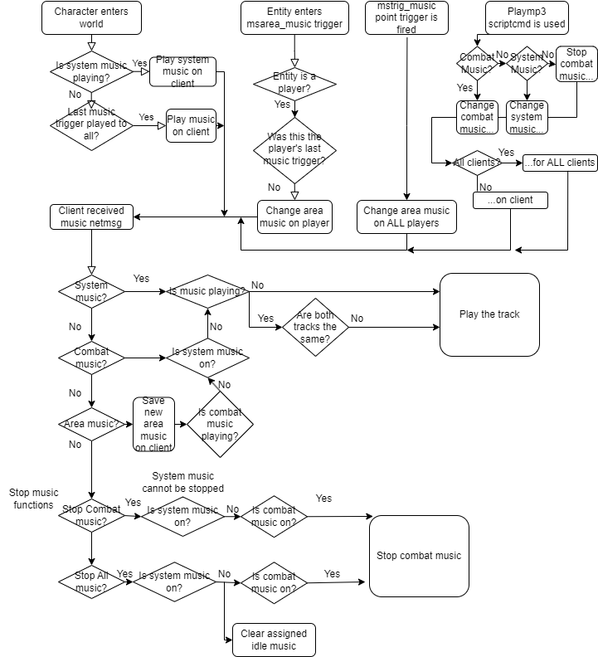

# Notes

* TODO: Stop sound console command should also reset the music system.
* TODO: Use fmods built in fade feature, rather than adjusting volume on think
* FIX B4 RELEASE: Daragoth does not play music properly
  + Unrelated to system
* FIX B4 RELEASE: Test if all music plays when a new character enters the world